**SQL_Transactions Assignment**

***Note*:** This assignment has to be completely performed in MYSQL Workbench. Select your OS type and download workbench from the given link. <https://dev.mysql.com/downloads/workbench/>

The version of MYSQL Workbench used for this assignment is 8.0.27

You can use any other stable version.

Follow:

[https://youtu.be/YSOY_NyOg40]( https://youtu.be/YSOY_NyOg40)

* Transactions group a set of tasks into a single execution unit. Each transaction begins with a specific task and ends when all the tasks in the group successfully complete.

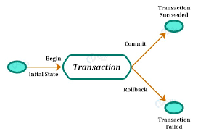

**TRANSACTION PROPERTIES:**

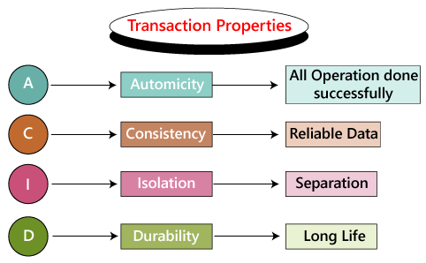

**Before beginning, lets first create a table and insert data.**

Create table ‘property’ having columns property_id, property_name,no-of_floors, ,no_of_flats, sqft_area

This is how our schema should look like

.

**PROPERTY TABLE**

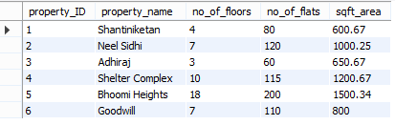

**NOTE: TURN OFF THE AUTO COMMIT OPTION IN MYSQL WORKBENCH**

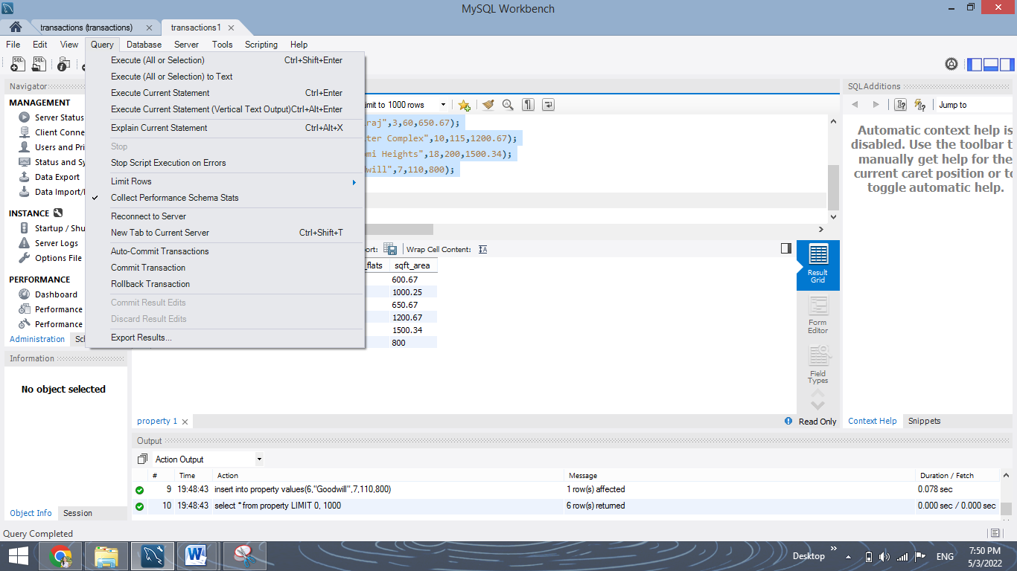

**1. COMMIT:**  The COMMIT command saves all the transactions to the database since the last COMMIT or ROLLBACK command. 

**Syntax:** 

COMMIT;

**Example:** 

DELETE FROM Student WHERE AGE = 20;

COMMIT;

**Q1. Insert a row in the table and commit it.**

**YOUR QUERY HERE:**

**Output:**

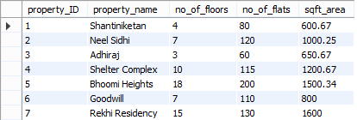

**Q2. Update the Property table, change the value of flats to 65 for “Adhiraj” property and commit this.**

**YOUR QUERY HERE:**

**Output:**

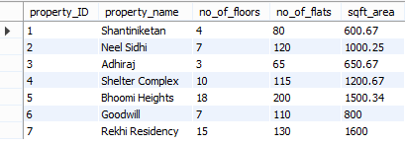

**2. ROLLBACK:** This command can only be used to undo transactions since the last COMMIT or ROLLBACK command was issued.

**Syntax:**

ROLLBACK;

**Example:**

DELETE FROM Student WHERE AGE = 20;

ROLLBACK;

**Q3. Insert some rows in the table and rollback them.**

**YOUR QUERY HERE:**

**Output:**

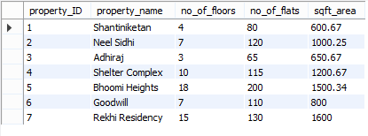

**Q4. Delete a row in the table and rollback it.**

**YOUR QUERY HERE:**

**Output:**



**3. SAVEPOINT:** creates points within the groups of transactions in which to ROLLBACK. A SAVEPOINT is a point in a transaction in which you can roll the transaction back to a certain point without rolling back the entire transaction. 

**Syntax for Savepoint command:**

SAVEPOINT SAVEPOINT_NAME;

**Syntax for rolling back to Savepoint command:**

ROLLBACK TO SAVEPOINT_NAME;

**Q5. Insert certain rows to the table and create a savepoint and rollback to this savepoint again after inserting another row.**

**YOUR QUERY HERE:**

**Output after inserting data and creating savepoint:**

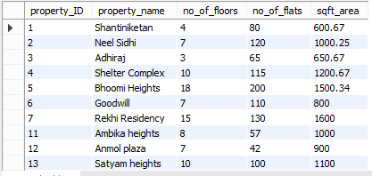

**Output after inserting another row and rolling back to savepoint:**

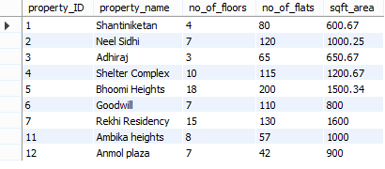

**Q6. Delete records having floors greater than equal to 10 and create a savepoint. Insert another row after this and rollback to the savepoint created above.**

**YOUR QUERY HERE:**

**Output after deleting records, creating savepoint and inserting a row:**

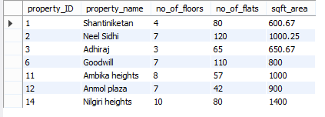

**Output after rolling back to the savepoint:**

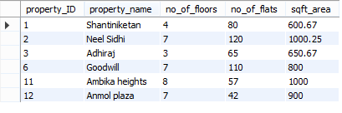

***Congratulations, you have just completed an assignment!!***



**FEEDBACK FORM**:

https://docs.google.com/forms/d/e/1FAIpQLScnAaAKvph9R3vINyCtOOMiav-tSMsRGlJReMaHyPjsXDlTIA/viewform